VOYAGE VISTA : ILLUMINATING INSIGHTS FROM UBER EXPEDITIONARY ANALYSIS



Overview:

**In this presentation, we will delve into fascinating world of Uber Expeditionary Analysis, uncovering mysteries and shedding light on its importance in various fields.**

DEFINITION**:**

**Uber Expeditionary Analysis is a comprehensive analytical approach that combines extensive research, data analysis and critical thinking to unravel complex problems and discover hidden insights.**

PROBLWM DEFINITION & DESIGN Thinking

Empathy map 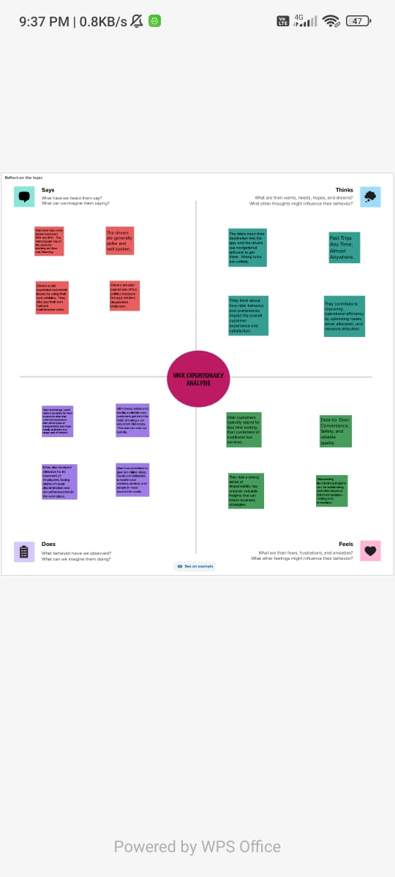

IDEATION & BRAINSTORMING MAP

ADVANTAGES :

Uber provides an on demand ride services, making it easy for users to book rides anytime, anywhere.

Uber can be more affordable than traditional taxis in many locations, and it offers various ride options to fit different budgets .

APPLICATIONS:

Uber Expeditionary analysis finds applications in diverse fields such as market research, security analysis, financial fore casting, trend prediction, scientific exploration.

It versatile nature allows it to adapt to different domains, providing valuable insights and driving innovation.

It serves as a powerful tool decision-makers, researchers, and analysts across various industries.

It empowers organisation to make data-driven decision.

CONCLUSION:

In conclusion, Uber Expeditionary Analysis is a powerful analytical approach that enables us to unravel complex problems, discover insights, and drive meaning full change.

Its application span across various industries, providing valuable benefits and organisation.

**THANKYOU**